Runner called out
Example 30: If, with a runner on first base and another on second, the batter (fourth in the batting order) hits to the shortstop, who throws to second in time to put out the runner, we will note the other runner’s arrival on third base with the number four, while the batter’s arrival on first base is by fielder’s choice. This is because the runner advanced on the hit (clearly, the shortstop realized he had no time to put out the runner, otherwise he would have thrown to third base), while the batter reached first base because the defense preferred to put out a more advanced runner.
WBSC |  | Traduction dans l’outil de scorage |  | Outil
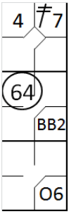 |  | /* Le première batteur frappe un double dans le champ gauche */  action { batter -> 2B7 }  /* Le batteur suivant gagne la première base sur un 'base on ball' */  action { batter -> BB }  /* Le batteur suivant frappe une balle vers l'arrêt court qui récupère la balle et la relaie  défenseur de la deuxième base pour retirer le coureur arrivant de la premier base */  action { batter -> O6 , runner1 -> 64, runner2 -> + } |  | 

